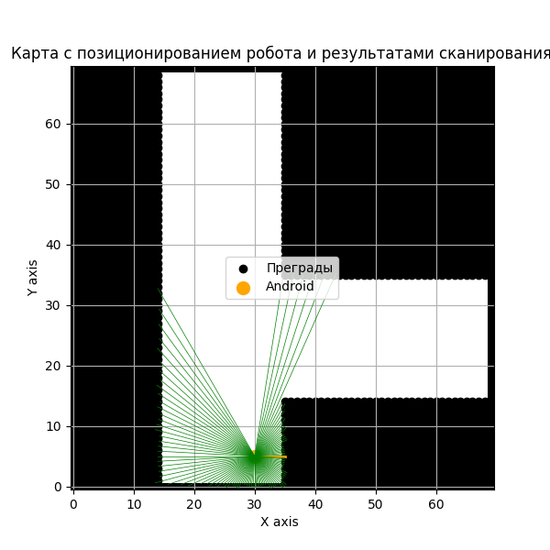

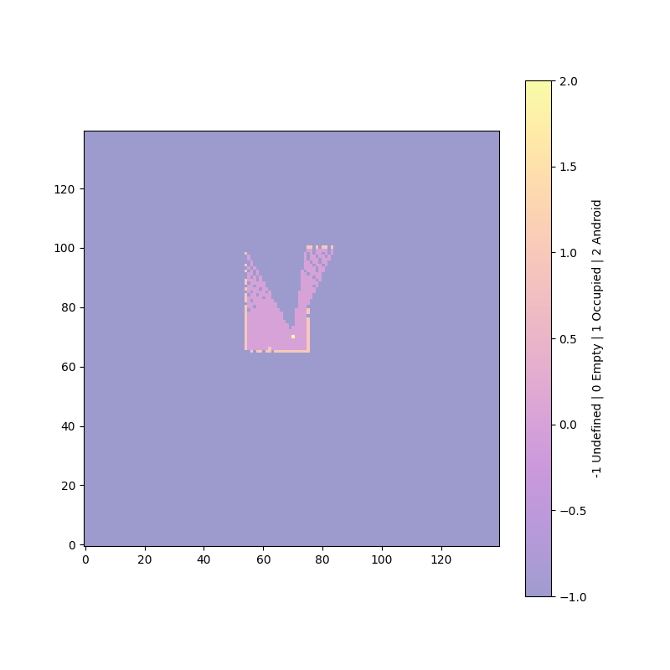

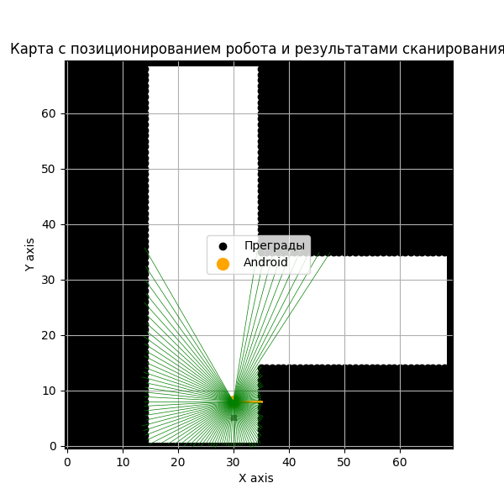

accumulated_actual_x_difference=0.0, actual_diff_y_accum=3.0, actual_diff_theta_accum=0.0

accumulated_predicted_x_difference=0.10269912538943116, estimated_diff_y_accum=3.005010966110693, estimated_diff_theta_accum=0.03162409436562762

Фактическая площадь помещения: totalBlocks=4900 openBlocks=2039

Область карты занятости: open_blocks=566

**i=1 Grid and Map area diff: 72.24%**

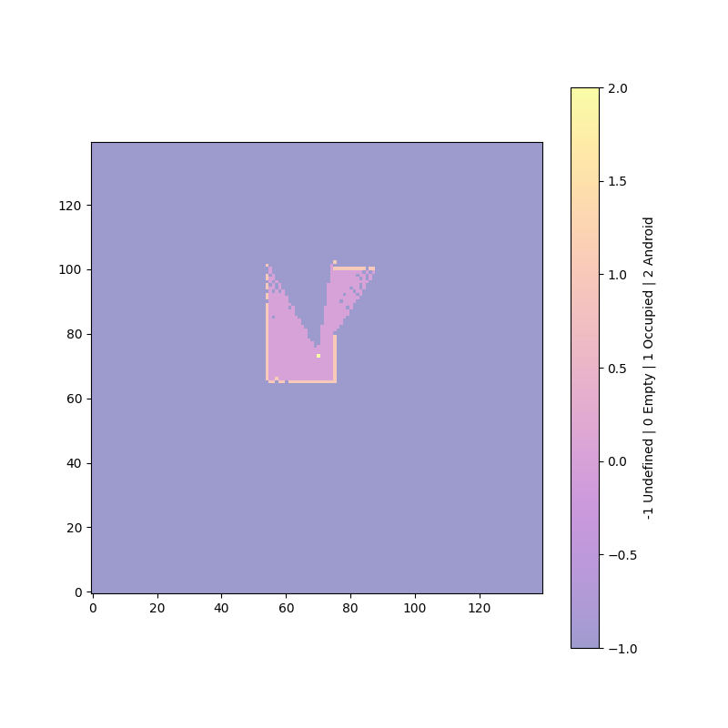

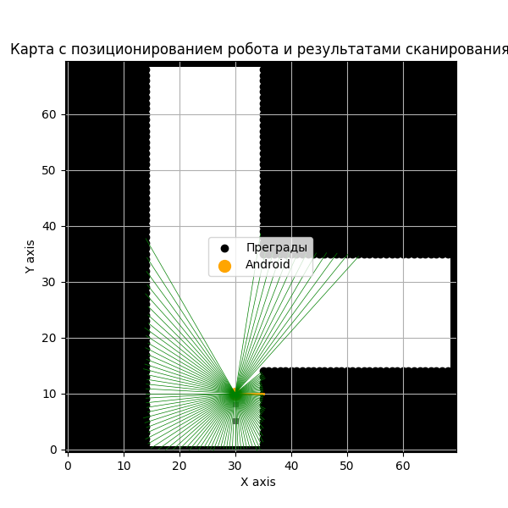

accumulated_actual_x_difference=0.0, actual_diff_y_accum=5.0, actual_diff_theta_accum=0.0

accumulated_predicted_x_difference=0.11457662195512519, estimated_diff_y_accum=4.897899210509914, estimated_diff_theta_accum=0.06293032447710303

Фактическая площадь помещения: totalBlocks=4900 openBlocks=2039

Область карты занятости: open_blocks=664

**i=2 Grid and Map area diff: 67.44%**

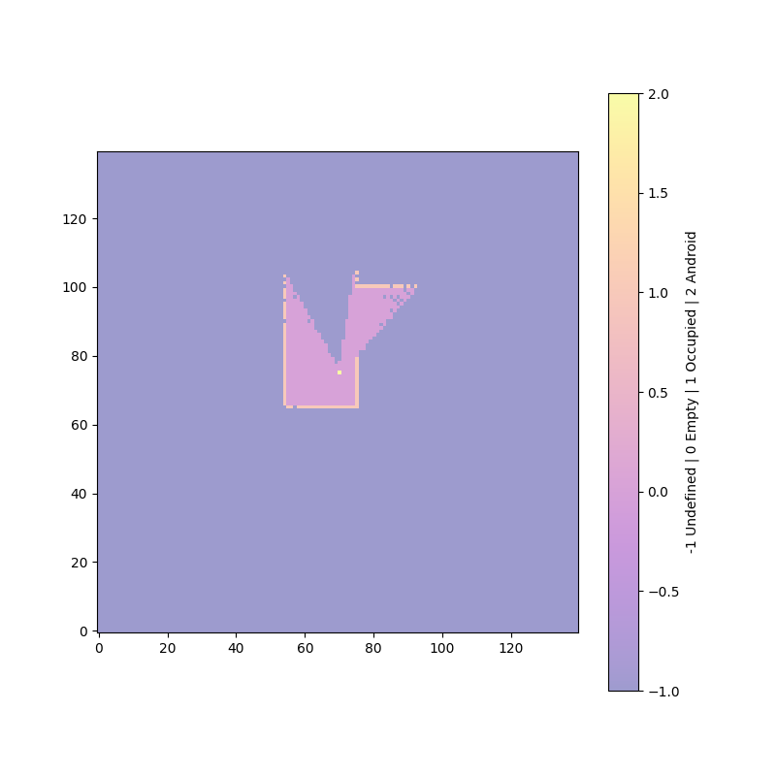

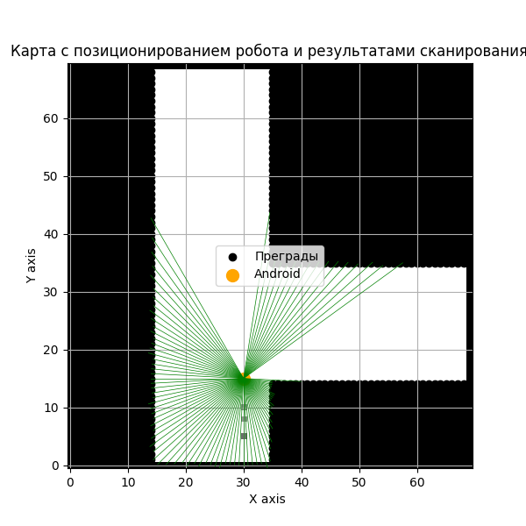

accumulated_actual_x_difference=0.0, actual_diff_y_accum=10.0, actual_diff_theta_accum=0.0

accumulated_predicted_x_difference=-0.006804466954558386, estimated_diff_y_accum=9.590458100645586, estimated_diff_theta_accum=0.09548940380329346

Фактическая площадь помещения: totalBlocks=4900 openBlocks=2039

Область карты занятости: open_blocks=791

**i=3 Grid and Map area diff: 61.21%**

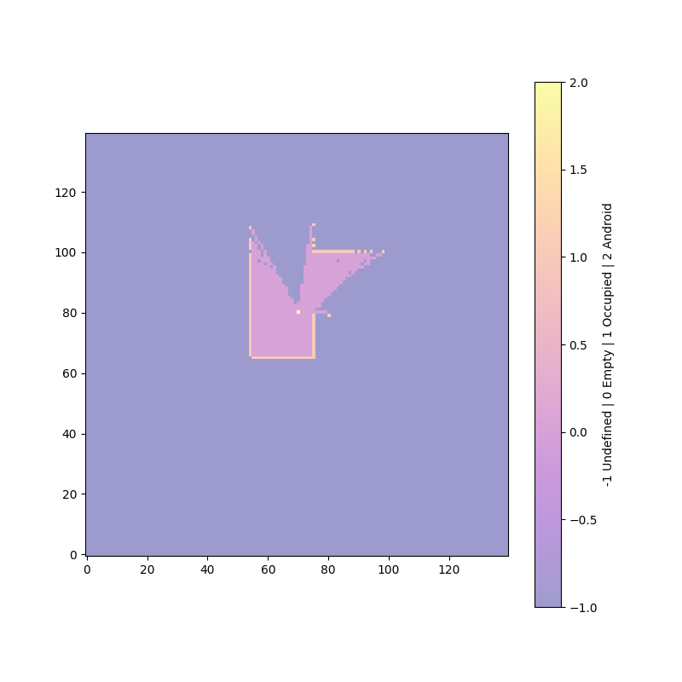

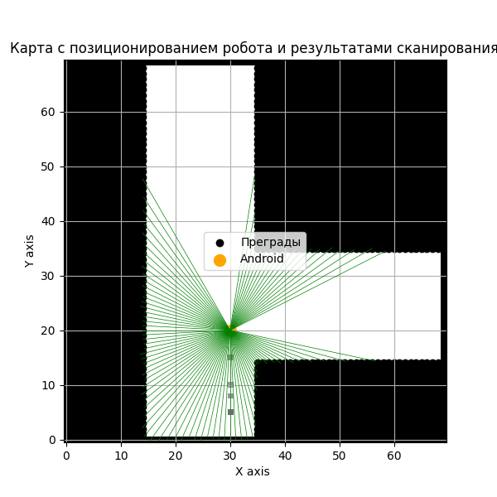

accumulated_actual_x_difference=0.0, actual_diff_y_accum=15.0, actual_diff_theta_accum=0.0

accumulated_predicted_x_difference=-1.204333017757746, estimated_diff_y_accum=14.313521194397207, estimated_diff_theta_accum=0.10548944547042834

Фактическая площадь помещения: totalBlocks=4900 openBlocks=2039

Область карты занятости: open_blocks=957

**i=4 Grid and Map area diff: 53.07%**

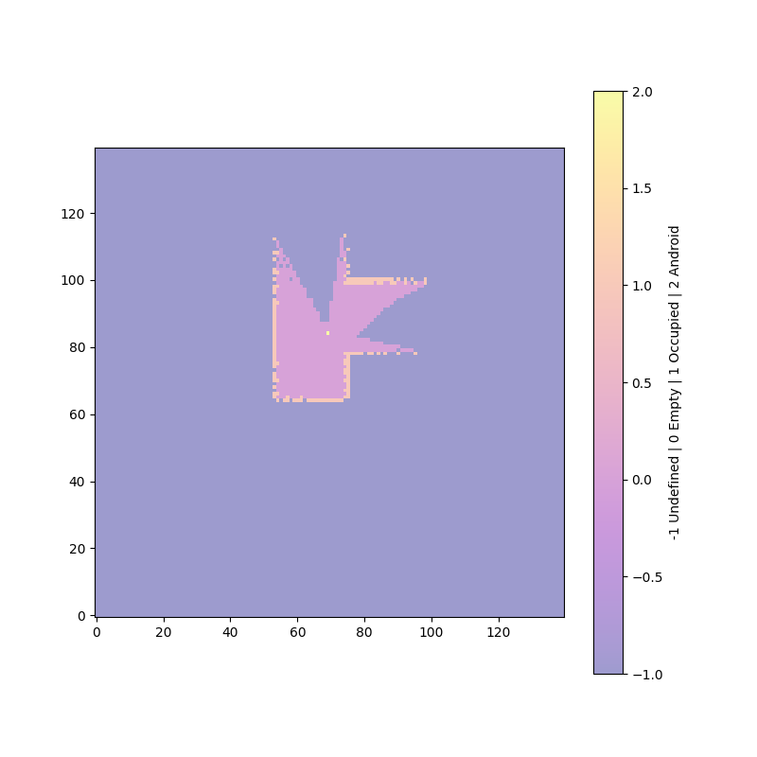

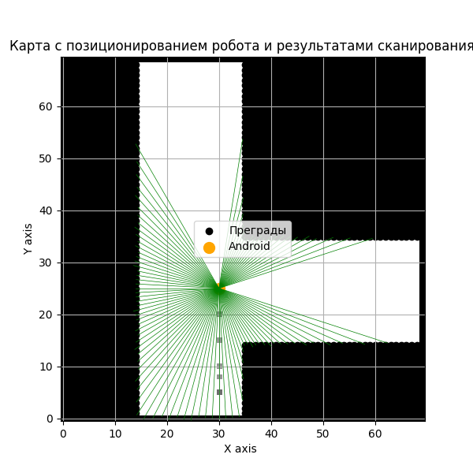

accumulated_actual_x_difference=0.0, actual_diff_y_accum=20.0, actual_diff_theta_accum=0.0

accumulated_predicted_x_difference=-1.6031799993196691, estimated_diff_y_accum=18.985534591021626, estimated_diff_theta_accum=0.1173216740586467

Фактическая площадь помещения: totalBlocks=4900 openBlocks=2039

Область карты занятости: open_blocks=1129

**i=5 Grid and Map area diff: 44.63%**

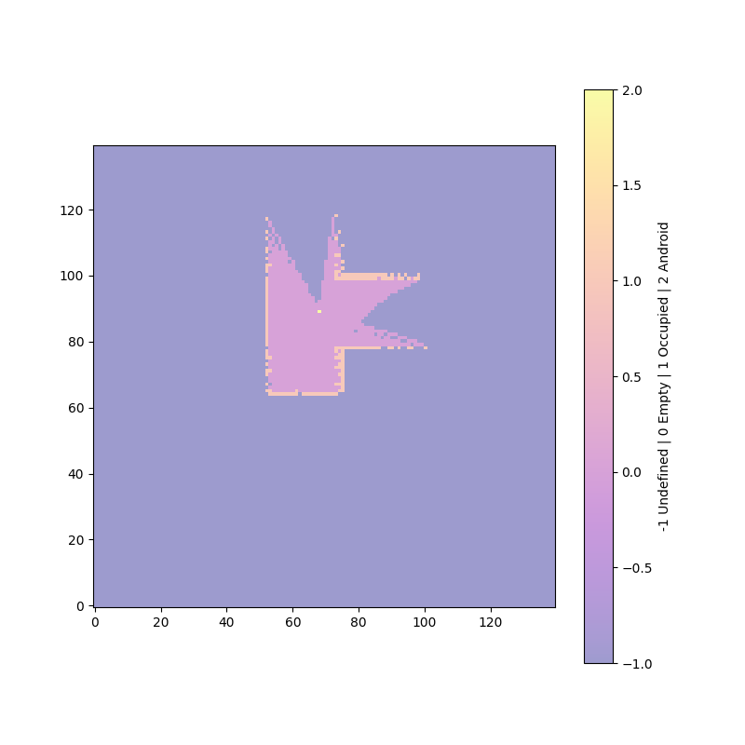

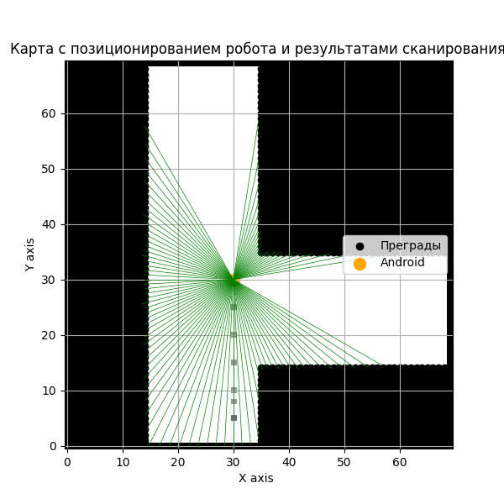

accumulated_actual_x_difference=0.0, actual_diff_y_accum=25.0, actual_diff_theta_accum=0.0

accumulated_predicted_x_difference=-1.6430507019344192, estimated_diff_y_accum=23.640310519956984, estimated_diff_theta_accum=0.12626597578315837

Фактическая площадь помещения: totalBlocks=4900 openBlocks=2039

Область карты занятости: open_blocks=1240

**i=6 Grid and Map area diff: 39.19%**

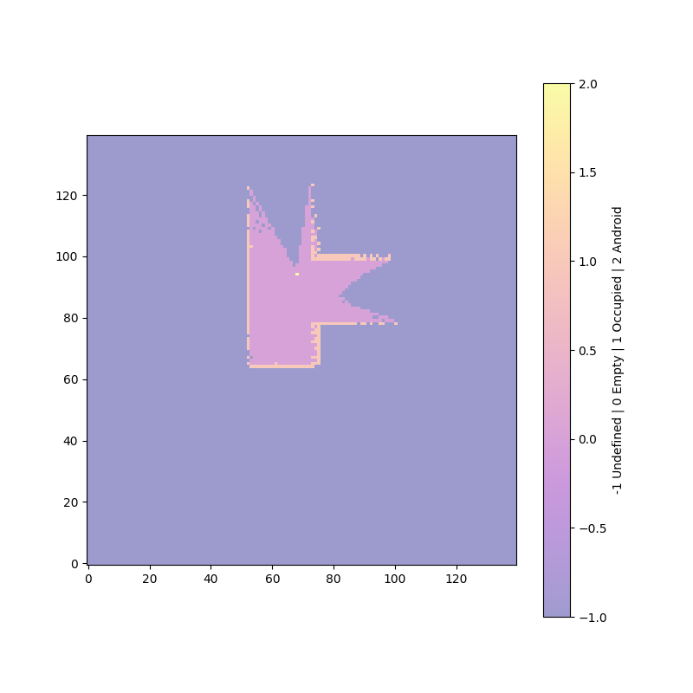

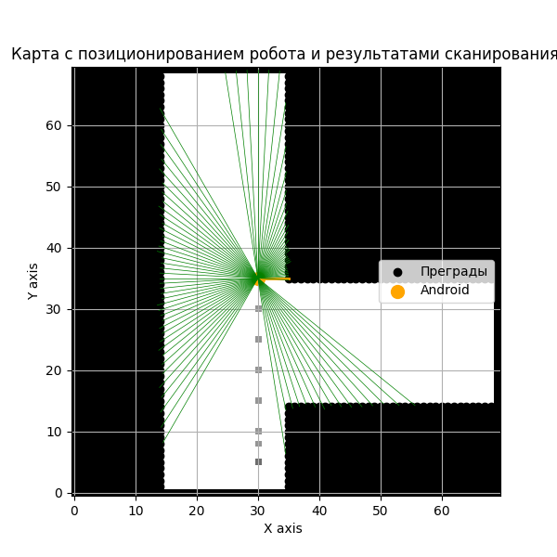

accumulated_actual_x_difference=0.0, actual_diff_y_accum=30.0, actual_diff_theta_accum=0.0

accumulated_predicted_x_difference=-1.9615775659191739, estimated_diff_y_accum=26.372063271543965, estimated_diff_theta_accum=0.07686459630034065

Фактическая площадь помещения: totalBlocks=4900 openBlocks=2039

Область карты занятости: open_blocks=1469

**i=7 Grid and Map area diff: 27.95%**

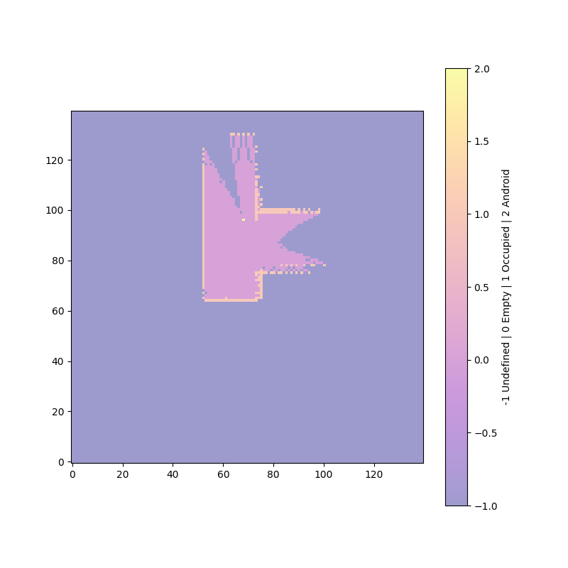

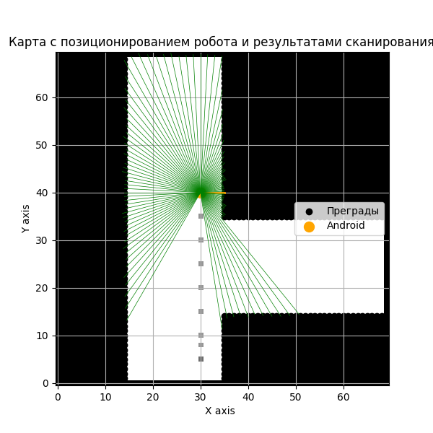

accumulated_actual_x_difference=0.0, actual_diff_y_accum=35.0, actual_diff_theta_accum=0.0

accumulated_predicted_x_difference=-1.9223180116730418, estimated_diff_y_accum=30.660724245446715, estimated_diff_theta_accum=0.0813367359821184

Фактическая площадь помещения: totalBlocks=4900 openBlocks=2039

Область карты занятости: open_blocks=1669

**i=8 Grid and Map area diff: 18.15%**

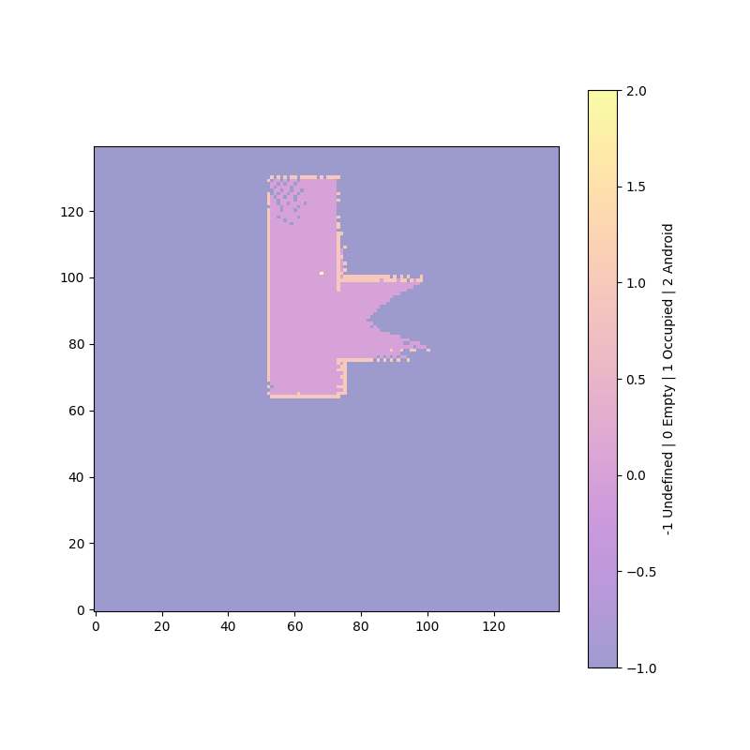

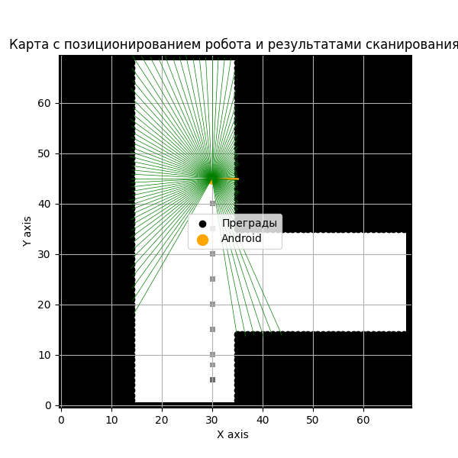

accumulated_actual_x_difference=0.0, actual_diff_y_accum=40.0, actual_diff_theta_accum=0.0

accumulated_predicted_x_difference=-1.9310858226847558, estimated_diff_y_accum=35.72229282551495, estimated_diff_theta_accum=0.0813367359821184

Фактическая площадь помещения: totalBlocks=4900 openBlocks=2039

Область карты занятости: open_blocks=1697

**i=9 Grid and Map area diff: 16.77%**

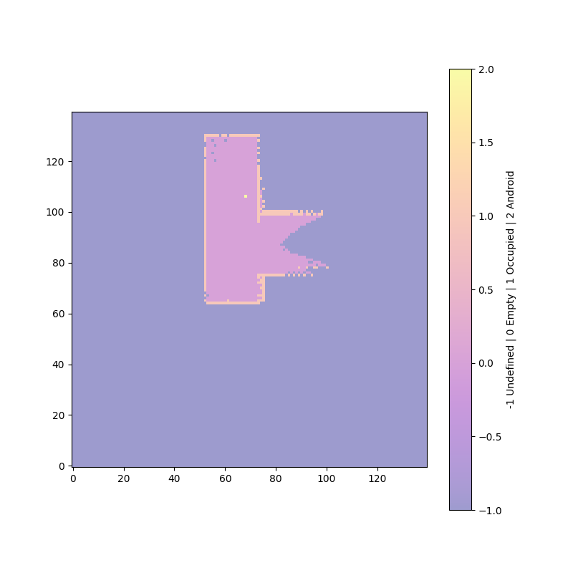

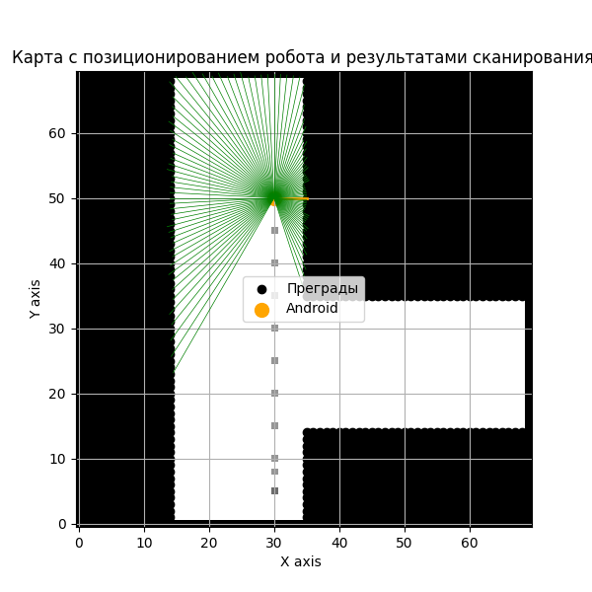

accumulated_actual_x_difference=0.0, actual_diff_y_accum=45.0, actual_diff_theta_accum=0.0

accumulated_predicted_x_difference=-1.9453165490348812, estimated_diff_y_accum=41.2233704666501, estimated_diff_theta_accum=0.08580887566389614

Фактическая площадь помещения: totalBlocks=4900 openBlocks=2039

Область карты занятости: open_blocks=1701

**i=10 Grid and Map area diff: 16.58%**

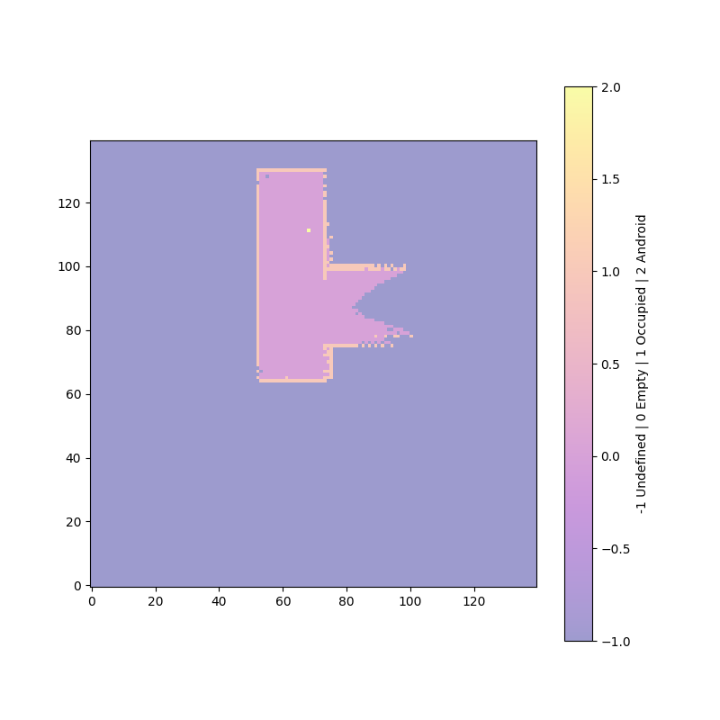

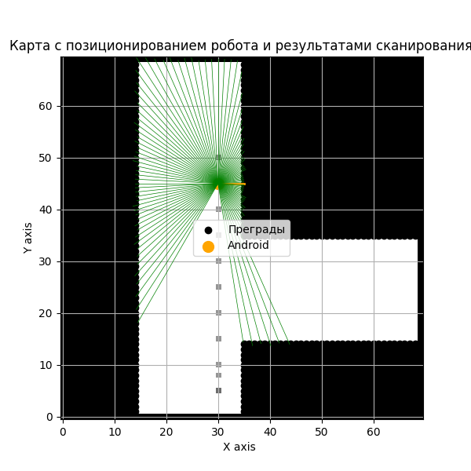

accumulated_actual_x_difference=0.0, actual_diff_y_accum=40.0, actual_diff_theta_accum=0.0

accumulated_predicted_x_difference=-2.965641742338271, estimated_diff_y_accum=40.156566221220295, estimated_diff_theta_accum=-0.334114946431038

Фактическая площадь помещения: totalBlocks=4900 openBlocks=2039

Область карты занятости: open_blocks=1780

**i=11 Grid and Map area diff: 12.70%**

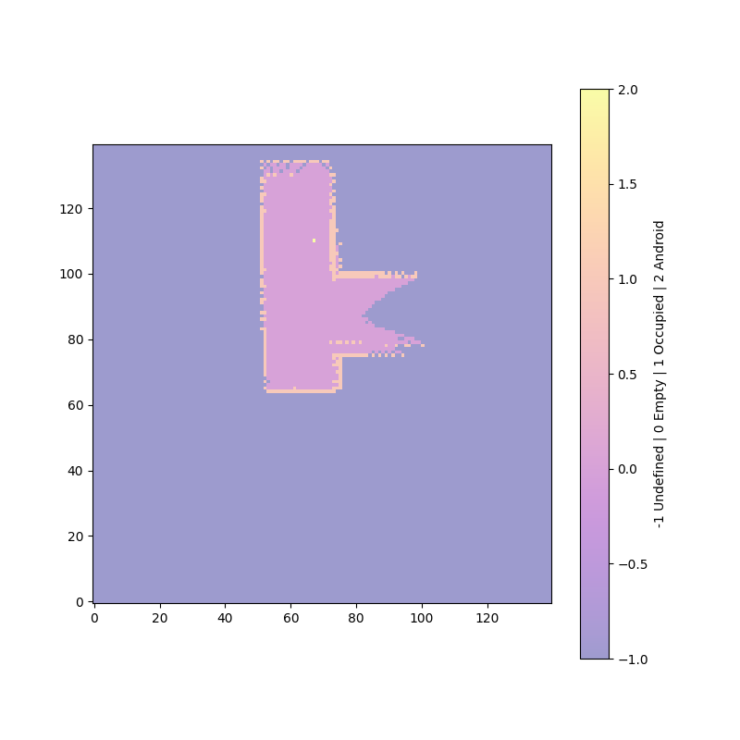

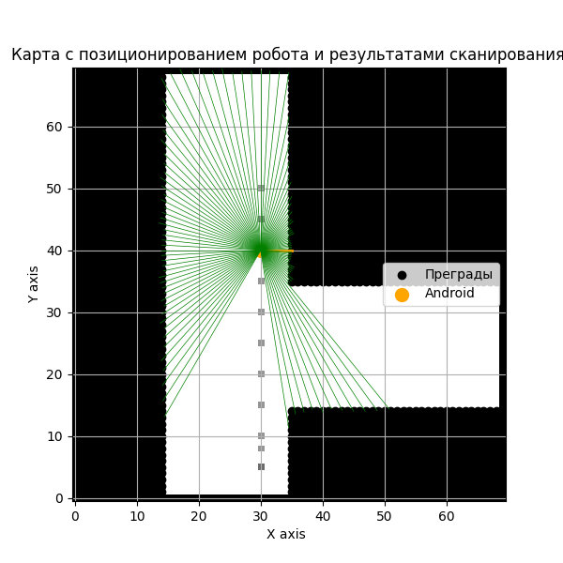

accumulated_actual_x_difference=0.0, actual_diff_y_accum=35.0, actual_diff_theta_accum=0.0

accumulated_predicted_x_difference=-3.0548669065914686, estimated_diff_y_accum=35.75890434203349, estimated_diff_theta_accum=-0.37461462769344833

Фактическая площадь помещения: totalBlocks=4900 openBlocks=2039

Область карты занятости: open_blocks=1801

**i=12 Grid and Map area diff: 11.67%**

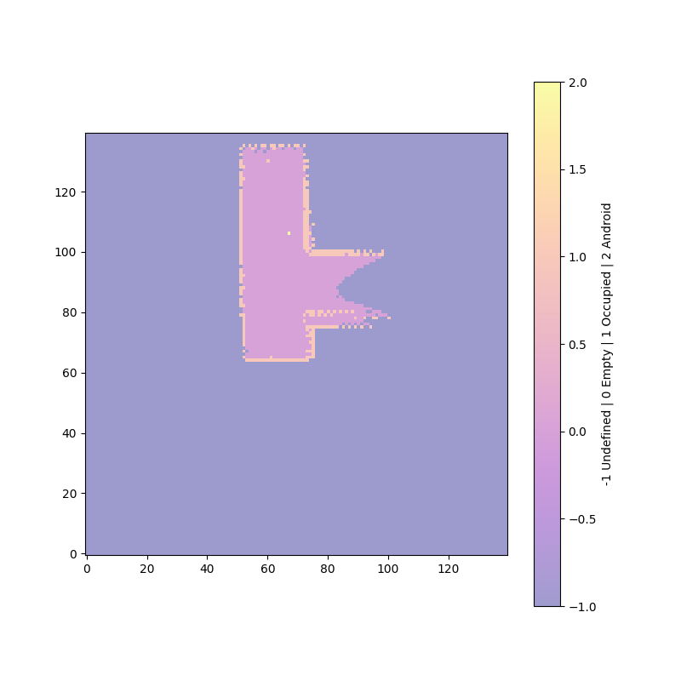

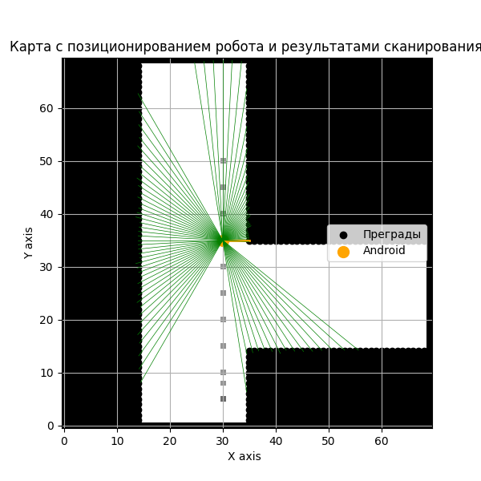

accumulated_actual_x_difference=0.0, actual_diff_y_accum=30.0, actual_diff_theta_accum=0.0

accumulated_predicted_x_difference=-3.1315261338989644, estimated_diff_y_accum=31.238487893400833, estimated_diff_theta_accum=-0.3991101375350533

Фактическая площадь помещения: totalBlocks=4900 openBlocks=2039

Область карты занятости: open_blocks=1821

**i=13 Grid and Map area diff: 10.69%**

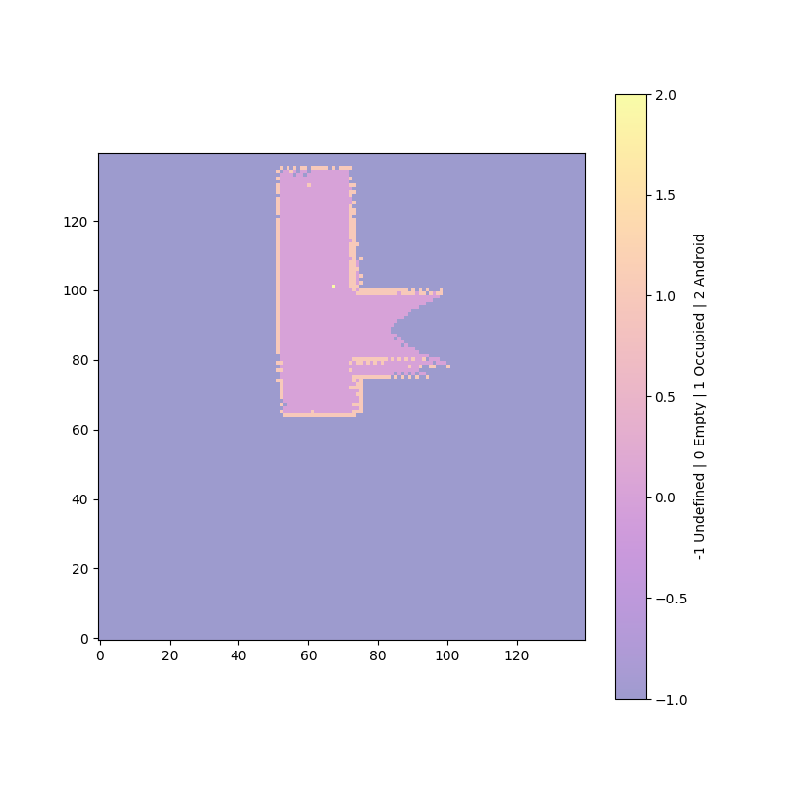

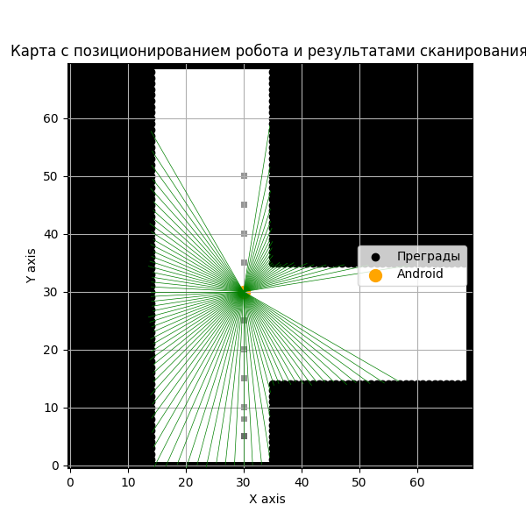

accumulated_actual_x_difference=0.0, actual_diff_y_accum=25.0, actual_diff_theta_accum=0.0

accumulated_predicted_x_difference=-4.424680291128157, estimated_diff_y_accum=29.343966995559263, estimated_diff_theta_accum=-0.4735585057123054

Фактическая площадь помещения: totalBlocks=4900 openBlocks=2039

Область карты занятости: open_blocks=1894

**i=14 Grid and Map area diff: 7.11%**